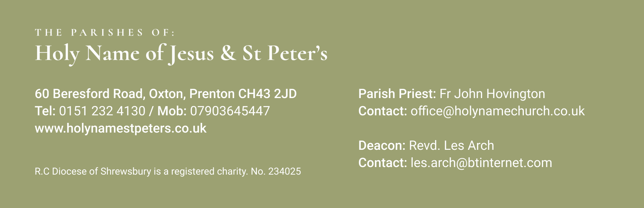

15th December 2024 3rd Sunday of Advent
Mass Times:
Saturday 14th December | 5.30pm | Holy Name
Sunday 15th December | 9.30am | St Peter’s
 | 11.30am | Holy Name | John K Smith
Monday 16th December | 9.30am | Holy Name
Tuesday 17th December | 9.30am  7.00pm | St Peter’s  Holy Name | Penitential Service
Wednesday 18th December | 9.30am | Holy Name | Joseph Hovington
Thursday 19th December | No Mass
Friday 20th December | 10.30am | Holy Name | Funeral of David Hazlegreaves
Saturday 21st December | 5.30pm | Holy Name
Sunday 22nd December | 9.30am | St Peter’s
 | 11.30am | Holy Name | Terence Whaley
Again, with the Newsletter, are the Sunday Mass Readings so that you have them to read at Mass in Church or online at home.
This weekend we light three candles on our Advent Wreath to mark that we are preparing for the great feast of Christmas, the Birth of our Saviour and Lord and it is getting closer!
As you will notice above, on Friday at, Holy Name, we will have the Funeral Service for David Hazlegreaves who died recently. His daughter Emma lives and works down south and arrangements have been made over the phone but we welcome Emma up to Birkenhead for Friday and I know that you will keep his family very much in your prayers this week.
I have received, this week, written confirmation of the Bishop’s visit to our Parishes for the 15th and 16th March 2025. After Christmas we will give more thought as to how we wish to welcome him for that weekend.
Without my mentioning it, a parishioner gave me some vouchers for one of the local major supermarkets. I am very thankful for their generosity and I have quickly found use for them and it will help a few families in this run up to Christmas. You have been very generous in the past as you always are. So, if anyone else wishes to help families in our parish in a similar way, please know that I will certainly find a worthy home or two for any vouchers that you wish to donate at any time.
I have also received an email from the St Vincent’s Centre on Grange Road West inviting any parishioner to come along and see the work they are doing for the needy of our town. St Vincent’s Conference Wirral is based within the Centre and although it only began this year, they have over 20 members many of whom volunteer in the Centre daily. In the last month, the Conference has helped over 100 individuals and families. This Conference has helped people with white goods, furniture, and befriending. Together, with The Meeting Place, we have even begun English classes once a week helping asylum seekers and refugees improve their English. I hope this email finds you well. As we approach the festive season, St Vincent’s Wirral is thrilled to announce that we are hosting a Christmas Grotto on Saturday 21st December, from 10am to 2pm. The grotto will be a magical experience for families in our community, spreading joy and bringing people together during this special time of year. We ask for a donation of £2 per child and is aimed at supporting families who may be struggling this time of year.

Very importantly, I want to remind you that our Penitential Service takes place this Tuesday Evening 17th December at 7pm in Holy Name Church. I hope this doesn’t clash with too many pre-Christmas parties or celebrations. I hope many of you will come and take part in this service of reconciliation in preparation for celebrating the birth of Christ into our lives.
***********************************
Your prayers Please pray for those who are celebrating significant anniversaries at this time of year and those who are sick: Kay Doran, Eve Perry, Emma Kelly, Geraldine Newton, Margaret Rose Gillam, John and Julia Delaney, Brian Farrell, Maureen Denyer, Patricia Lacey, Paola Fregona, Kevin Nolan, Daniel Dobbs, Anja Welsh-Smyth, Connor O’Mahoney, Paschal Welsh, Jenny Fogg, Nelia Fregona and Maria Jones.

***********************************
Food Bank I thank you for your support to the food bank. Please leave any donations in the Porch of St Peter’s Church or the Presbytery Porch at Holy Name. Items particularly needed at present include: Tinned fruit, tinned potatoes, tinned spaghetti , cereal and treats (chocolate etc).

***********************************
Gifts for the Crib - you are invited to bring gifts to the Crib after all Christmas masses at both St Peter's and Holy Name. These gifts will be donated to the Women's Refuge and used for birthday/welcome presents throughout the year. Please choose gifts which are suitable for women or children of any age and label the parcel to indicate who it is for and age.(eg: if for a child)

***********************************

