Home Learning
https://explorify.wellcome.ac.uk/
Odd One Out – Weird Walkers
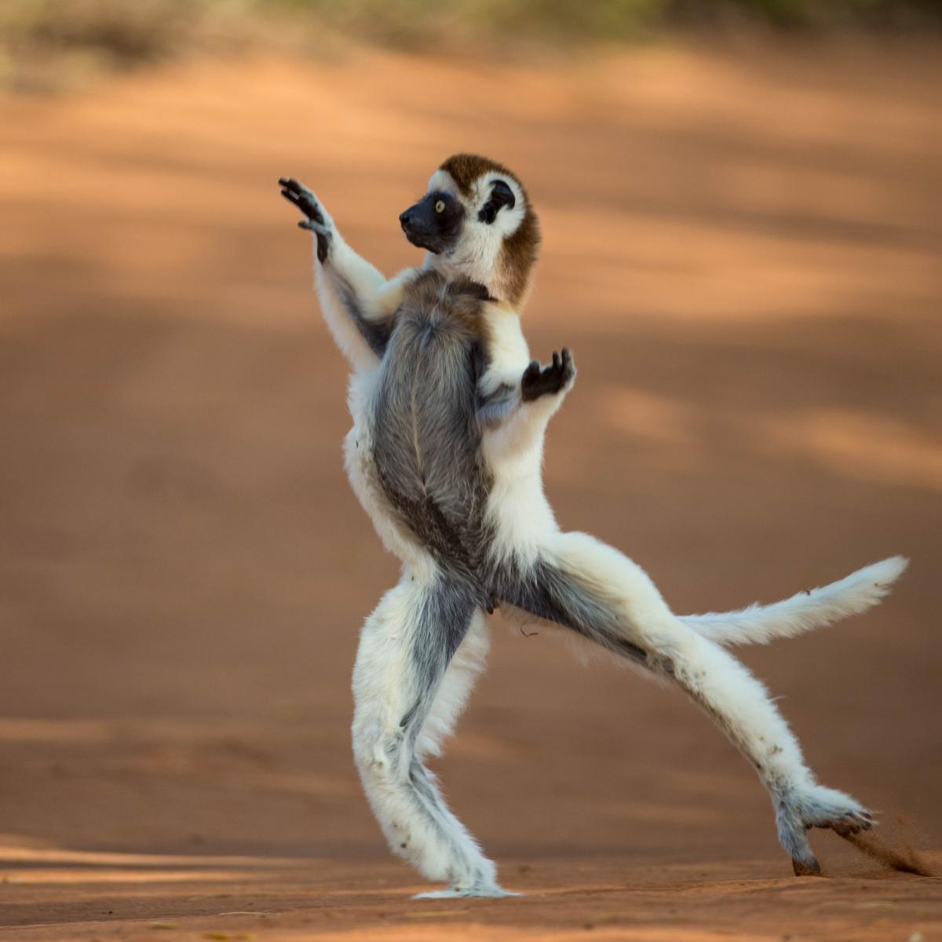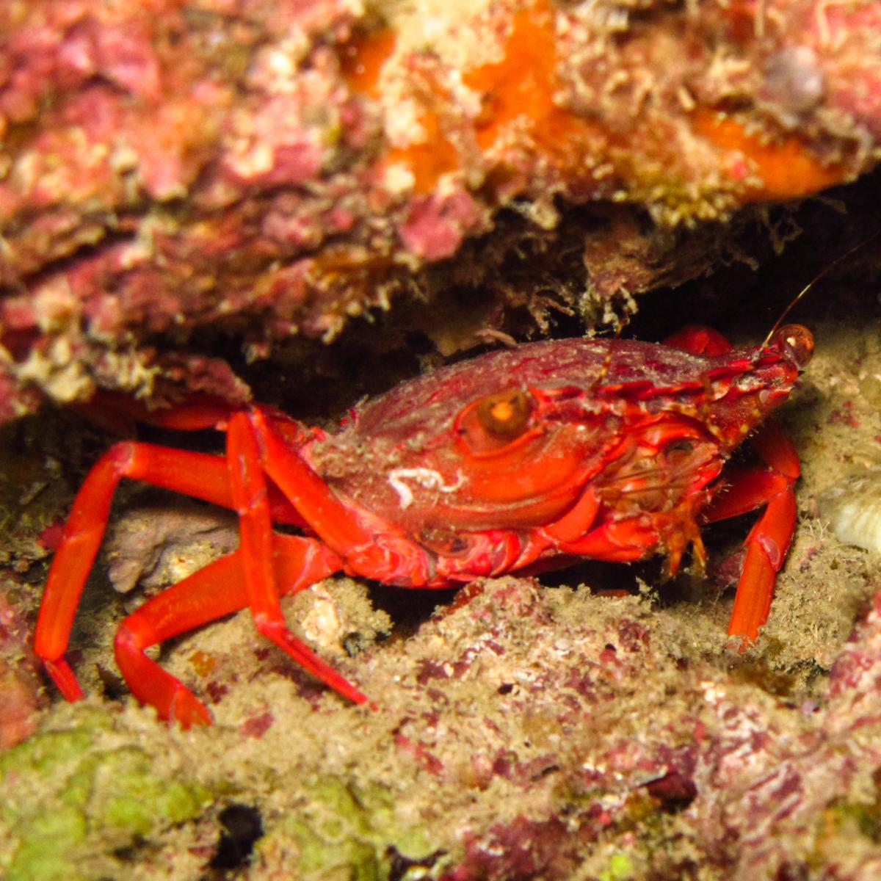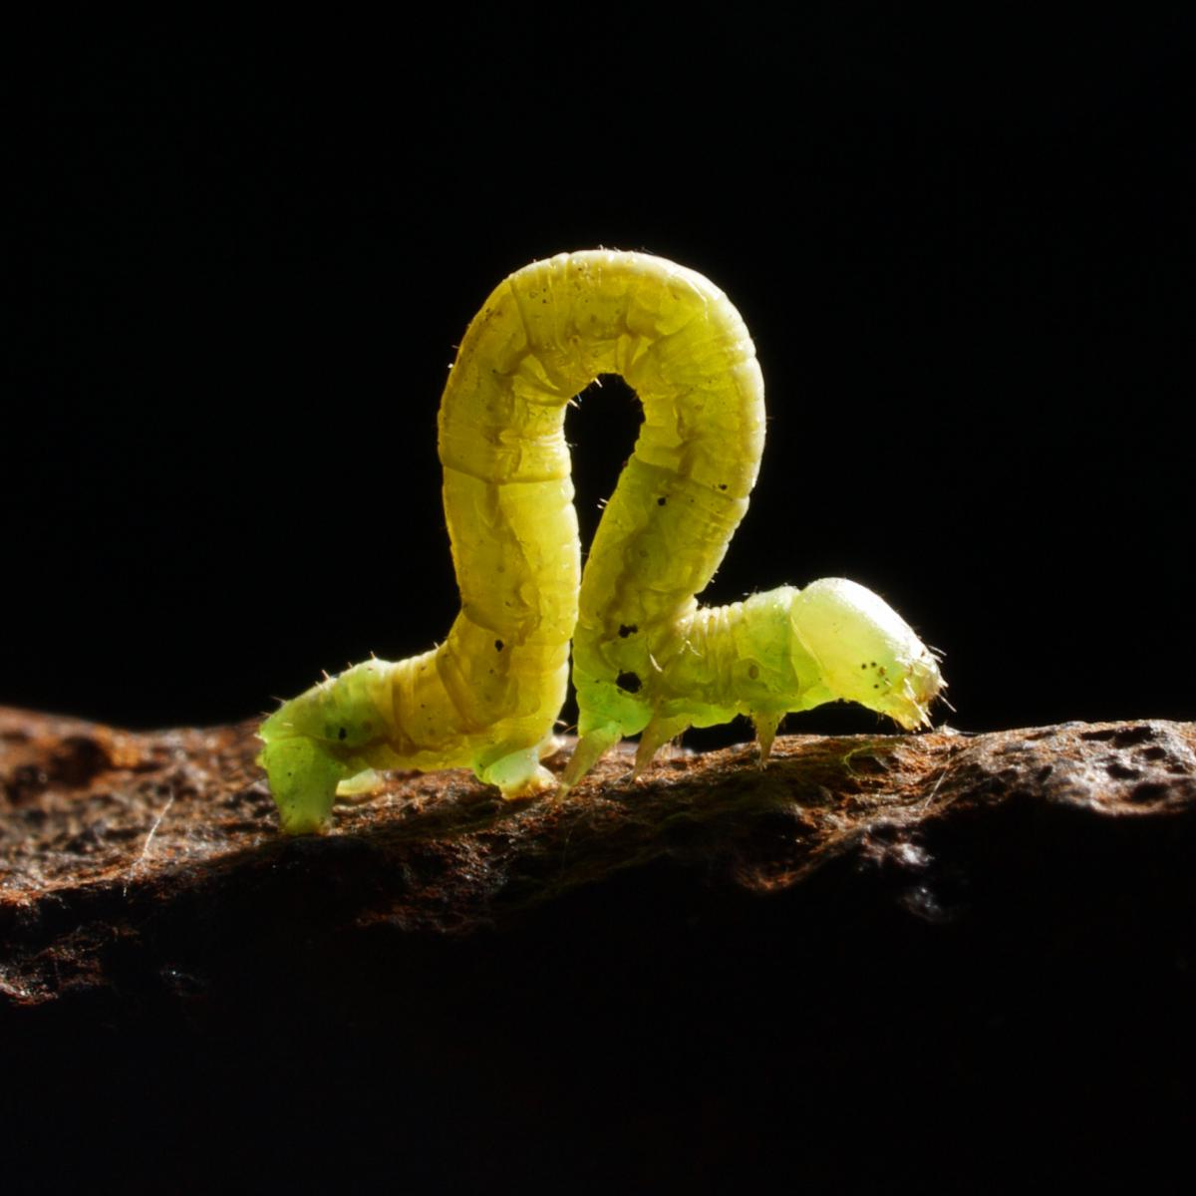
- Look at the three images above. Come up with as many similarities and differences as you can.
Think about:
- appearance
- what they do
- where they might be found
- Now decide which one is the odd one out and why. Be sure to explain your reason - there is no wrong answer!

---------------------------------------------------------------------------------------------

Background science
The three animals are lemurs, which are tree-dwelling primates that are unique to Madagascar; crabs, which are invertebrates and do not have a skeleton but have a hard outer shell; and inchworms, which are the caterpillar of the geometer moth.
----------------------------------------------------------------------------------------------
Task
Watch these animals in action:
See how a crab scuttles across a beach, https://vimeo.com/134694670;
watch a dancing lemur leap around https://www.youtube.com/watch?v=fHCQ5-1n07M;
observe the inchworm slinking along a branch https://vimeo.com/27763528.
Can you think of other animals that walk in unexpected ways?
Create a fact file for one of these animals.

