Monday 11th May 2020

Dear Parents and Carers

I am sure, after the Prime Minister’s statement last night, you will have many questions to ask. We too have lots of questions that need clarification.

At the moment, for us in school, there is no change in guidance. We will provide care for the children of key workers whose employment is critical to the COVID-19 response, but only for those who cannot be safely cared for at home.

We have not yet received any information to support us with this new plan to start the phased reopening of some year groups. We expect that we will receive further information and clarification from the DFE soon.

We will need clear guidance to plan how it is possible to social distance in schools and keep our children, teachers and families safe; how we may start to phase groups of children to return and what this looks like. Please be assured that we will not reopen until we are properly prepared to do so.

We will keep you informed as we move forward. Please try not to worry. Our plan for now is to continue to provide activities for learning at home, to keep contact with you and to continue to support each other at this difficult and uncertain time.

Stay Safe

Yours Sincerely

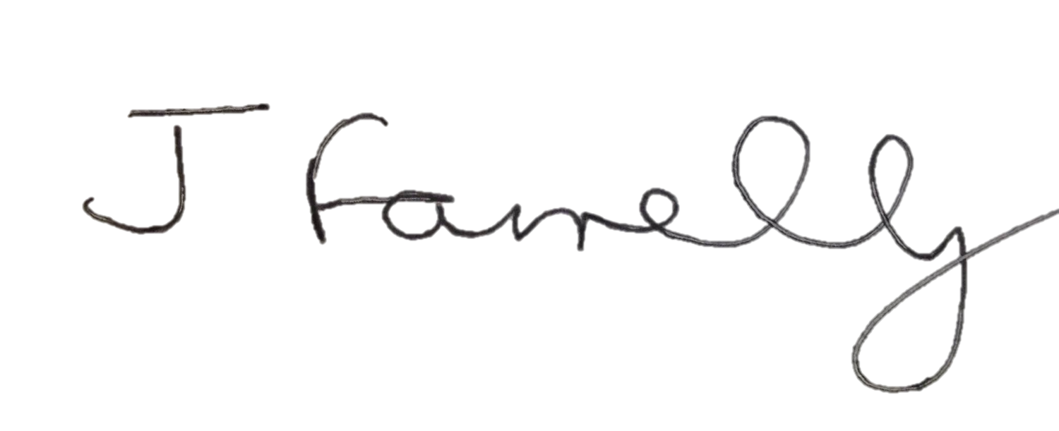
Mrs J Farrelly

