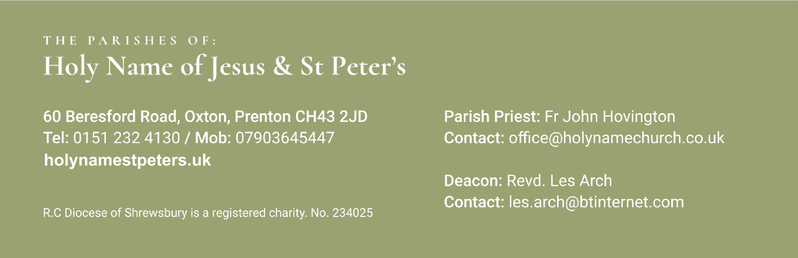

15th October 2023  Twenty Eighth Sunday

|  |  |  |  |
| --- | --- | --- | --- |
| Saturday 14th Oct | 5.30pm | Holy Name | Christopher Hovington |
| Sunday 15th Oct | 9.30am | St Peter’s |  |
|  | 11.30am | Holy Name |  |
| Monday 16h Oct | 9.30am | Holy Name |  |
| Tuesday 17th Oct 26th Sept |  | No Mass |  |
| Wednesday 18th Oct | 9.30am | Holy Name |  |
| Thursday 19th Oct | No Mass |  |  |
| Friday 20th Oct | 9.30am | St Peter’s |  |
| Saturday 21st Oct | 5.30pm | Holy Name | Parishioners |
| Sunday 22nd Oct | 9.30am | St Peter’s |  |
|  | 11.30am | Holy Name |  |

Again, with the Newsletter, are the Sunday Mass Readings so that you have them to read at Mass in Church or online at home.

************************************

Your prayers Please pray for those who *are celebrating significant anniversaries at this time of year* and those who are sick: Emma Kelly, Geraldine Newton, Margaret Rose Gillam, John and Julia Delaney, Brian Farrell, Maureen Denyer, Patricia Lacey, Paola Fregona, Kevin Nolan, Daniel Dobbs, Anja Welsh-Smyth,Connor O’Mahoney, Joan Smith, Paschal Welsh, Jenny Fogg, Derek Athertonand Doreen Sutton.

************************************

Food Bank I thank you for your support to the food bank. Please leave any donations in the Porch of St Peter’s Church or the Presbytery Porch at Holy Name. Your support is particularly important as might be expected in these times of hardship, food donations have not been keeping pace with increased need. Items particularly needed at present include: Tinned fruit, long life milk, rice pudding, squash, pasta sauce and female hygiene. We have plenty of beans.

***********************************

St Peter’s Warm Space St Peter’s School have joined the Noctorum Collaboration, (Hashtag)togetherwearestronger, and are providing a warm space 3pm-5pm on Monday and Tuesday each week. Everyone is welcome, free food will be available together with hot drinks and much more.

************************************



Oxton Mens Dinner This year’s Dinner is taking place on Friday 10th November at St Anselms at 7.15 for 7.45 pm. Our principal charity is the Ark project for homeless people. The guest speaker will be Revd Steve Mansfield. Tickets £25 (if paid for on or before 27th October)are available from the usual sources or through [team@oxtonmensdinner.com](mailto:team@oxtonmensdinner.com)

************************************

Parish Fundraiser Event The Social Committee are holding a fund raising Quiz Night,  Saturday  21st October at 7.30pm  in the Parish Centre (HUT)   Tickets are £5 and include a light buffet. Bring your own drinks (wine glasses provided). Tickets available by contacting Pauline Eriksen 07982314029 or [paulineeriksen@yahoo.co.uk](mailto:paulineeriksen@yahoo.co.uk)

************************************

Upton Hall School Mass Upton Hall’s school Mass will be held in the Metropolitan Cathedral on Saturday 4th November at 11 am. The Mass is to celebrate Catholic Education and to pray for present members of our School Community. Everyone associated with Upton Hall School present or past is welcome to attend.