 | RA 045 Christmas Performances in school COVID 19 v1 | RISK ASSESSMENT  RECORDING FORM

Location or School  Address: St Peter’s Catholic Primary School | Date assessment  Undertaken 02.12.21 | Assessment undertaken  by : Jeanne Fairbrother and Sarah Parry
Activity or  situation Christmas Performances in school COVID 19 | Review  date: Daily review prior to the performances | Signature: SJParry

Background information

Christmas Performances 2021
Years 1&2 – Monday 13th December 2021 @ 1.30pm
Tuesday 14th December 2021 @ 9.30am
EYFS – Tuesday 14th December @ 1.30pm
Wednesday 15th December @ 9.30pm
KS2 – Carol Service – Wednesday 15th December @ 2.00pm

The Legislation
The Health & Safety at Work Act 1974
The Management of Health & Safety at Work Regulations 1999

1) Hazard / Activity | 2) Who can be harmed and how? | 3) What controls exist to reduce the risk?  Have you followed the hierarchy of controls (eliminate, substitute etc)? | Risk Score  Consequence  X Likelihood | 4) Any further action.  This should be included in the action plan (5)
Parents & visitors attending performance | Staff, pupils, visitors to school – increased risk of transmission. | - Anyone who has any of the symptoms of COVID 19 or is unwell is asked not to attend on invites, Parent mail etc.  - School requests that attendees take a LFD test on the day prior to the event.  - We will hold multiple performances to avoid overcrowding of spectators (See dates above)  - School will consider holding the event outside if situations changes  - School will ventilate indoor spaces as much as possible/practical. All external Hall doors will be opened and windows kept fully open throughout.  - School will ventilate the hall well for at least 15 mins before and after any event and ensure all touch surfaces are cleaned before use by another group  - Access only with ticket obtained in advance from school.  - Contact details provided in advance at ticket purchase stage to assist Track and Trace  - NHS Track and Trace QR code check in or contact details recorded of all attendees  - Sanitiser will be available at all entrances and staff and notices will reinforce good hand and respiratory hygiene measures  - All adults are required to wear face coverings in all communal areas (auditorium/hall) – unless exempt.  - Masks to be worn by audience  - Audience seating or standing arrangements take account of social distancing. Capacity of hall has been significantly reduced and audience will be required to remain in seats unless instructed. No standing will be permitted.  - A designated toilet (Staff area closest to the hall) will be made available in case of emergencies and will be cleaned thoroughly before and after performances. Additional cleaning wipes will be available for individual use.  - Venue used is thoroughly cleaned before and after the event.  - No attendee will have access into the wider school building or have direct contact with any pupil.  - If school is in an outbreak situation – The event will be postponed/rescheduled/re-designed to reduce risk. This may be a remote event, recorded and distributed to parents. | 3X2=6
Staff & pupils participating in the performance - singing, playing instruments. | Staff, pupils, visitors to school – increased risk of transmission. | - Playing instruments and singing in groups should take place outdoors wherever possible. If indoors, numbers will be limited in relation to the space. KS2 Carol service will take place either outdoors (Weather permitting) or in the church to allow for extra space.  - Max of 1 class of no more than 22 will be singing in a well-ventilated space.  - Pupils to be side by side, not face to face  - Staff to maintain 2m social distancing (face to face contact to be avoided where possible)  - School will keep performance times as short as possible and  - Pupils will sing ‘quietly’ to reduce aerosols.  - School has read and completed RA 023  Music in schools COVID 19 (below) and followed the general guidance and measures recommend to reduce the risk of transmission | 3X2=6
Accident during Drama performance requiring first aid | Staff Pupils and Guests | - Access to first aid will be in the office (if performance is in school) and in the vestibule (if performance is in church) | 2x2=4 | Ensure sufficient FA equipment available
Fire evacuation leading to injuries | Staff pupils’ and guests | - H&S rep (C.Smith) to review current Fire Risk Assessment and ensure it fits the needs of the performance  - Pre performance brief with all staff engaged in production on fire evacuation procedures and any roles and responsibilities  - Consider any visitors to the event who need assistance to evacuate in the event of a fire.  - Fire safety announcement made before each performance  - Person in charge to identify specific roles including checking fire panel. This may be completed in conjunction with site staff | 2x2=4 | Review FRA and ensure fit for performance  Site manager to identify specific roles including checking fire panel.

Risk Rating | Action Required
17 - 25 | Unacceptable – stop activity and make immediate improvements
10 - 16 | Urgent action – take immediate action and stop activity, if necessary, maintain existing controls vigorously
5 - 9 | Action – Improve within specific timescales
3 - 4 | Monitor – but look to improve at review or if there is a significant change
1 - 2 | Acceptable – no further action but ensure controls are maintained & reviewed
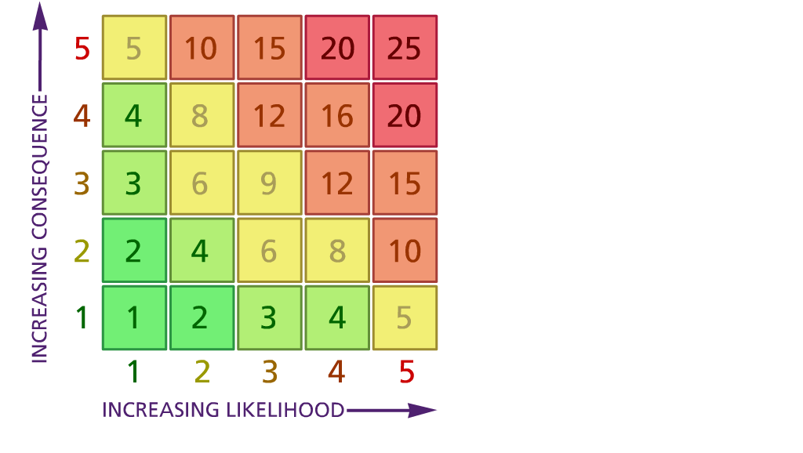

(1) List hazards something with the potential to cause harm here
(2) List groups of people who are especially at risk from the significant hazards which you have identified
- List existing controls here or note where the information may be found. Then try to quantify the level of risk the likelihood of harm arising that remains when the existing controls are in place based on the number of persons affected, how often they are exposed to the hazard and the severity of any consequence. Use this column to list the controls that you might take and develop all or some of that list into a workable action plan. Have regard for the level of risk, the cost of any action and the benefit you expect to gain. Agree the action plan with your team leader and make a note of it overleaf. If it is agreed that no further action is to be taken this too should be noted.
Likelihood: Consequence:

5 – Very likely 5 – Catastrophic

4 – Likely 4 – Major
3 – Fairly likely 3 – Moderate

2 – Unlikely 2 – Minor

1 – Very unlikely 1 – Insignificant

(5) ACTION PLAN

 | 5. Action plan | Responsible | Completed
1 | Ensure sufficient FA equipment available | Admin team | Prior to performances
2 | Review FRA and ensure fit for performance  Site manager to identify specific roles including checking fire panel. | C.Smith & Site manager | Prior to performance
Action plan agreed by
Sarah Parry (HT) Claire Smith (SLT/H&S) Helen Collinson (CofG)
02.12.21

