Home Learning
https://explorify.wellcome.ac.uk/
Odd One Out – Functional Footwear
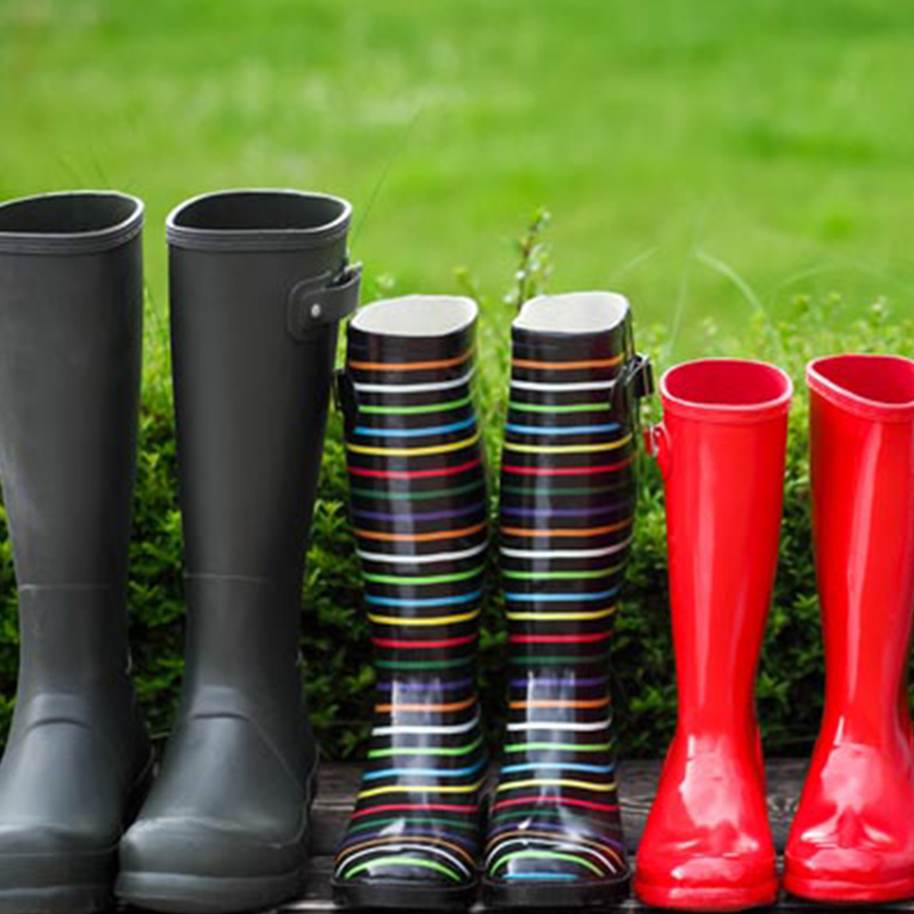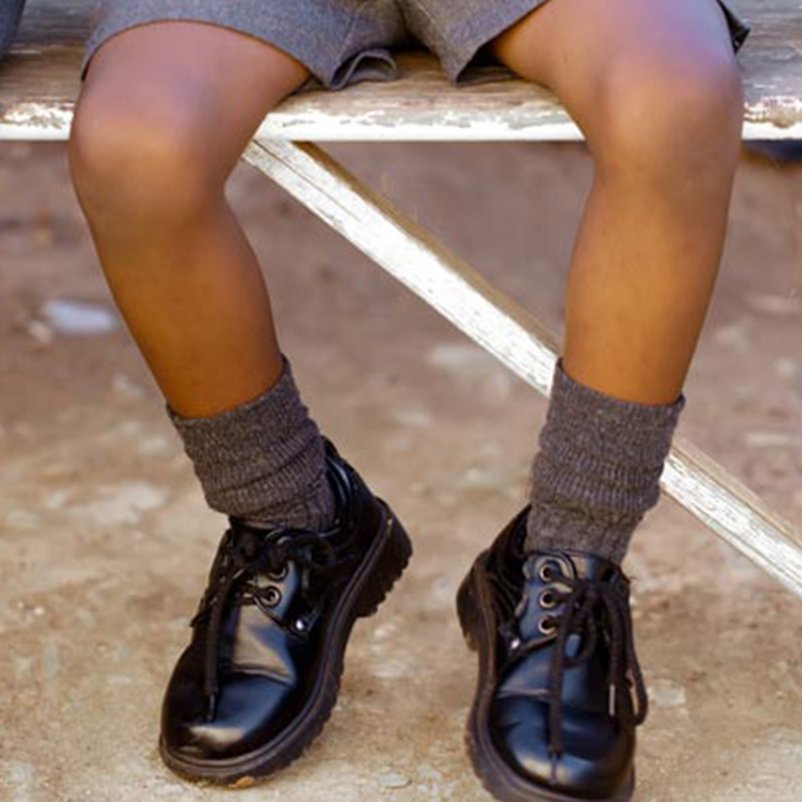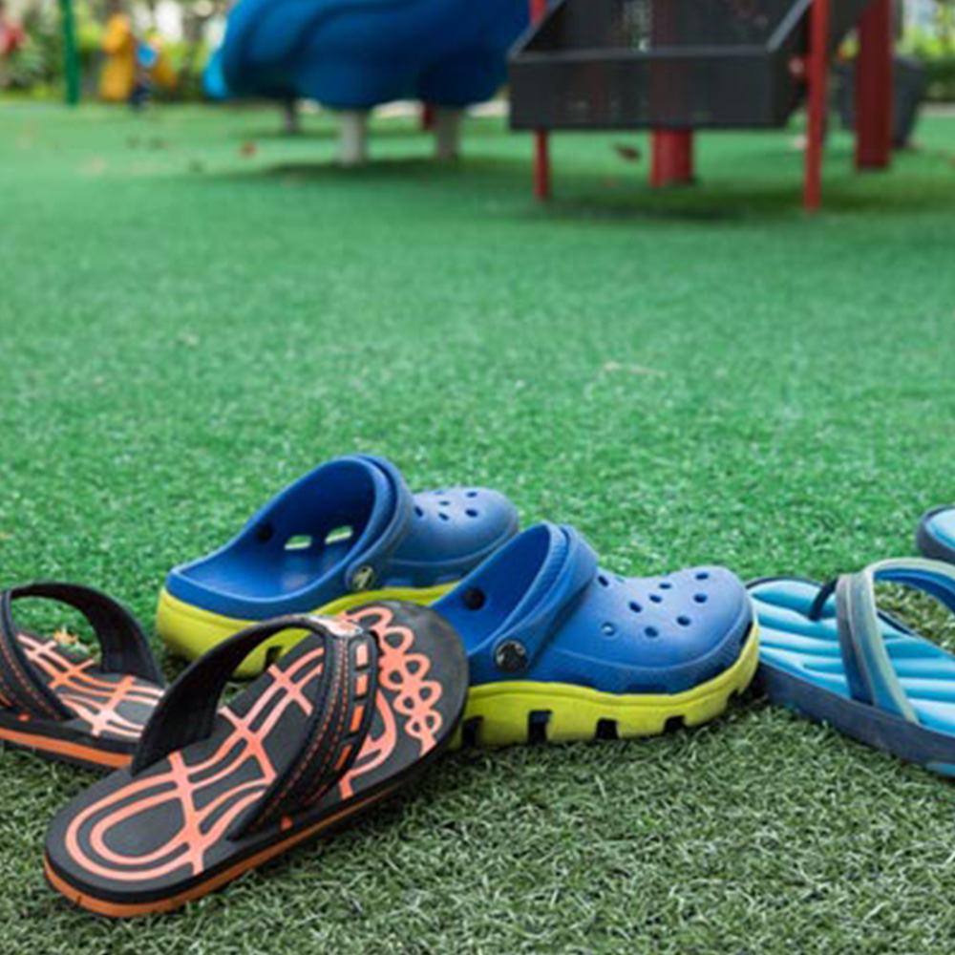
- Look at the three images above. Come up with as many similarities and differences as you can.
Think about:
- appearance
- what they do
- where they might be found
- Now decide which one is the odd one out and why. Be sure to explain your reason - there is no wrong answer!

---------------------------------------------------------------------------------------------

Background science
In the past, the simplest way to protect your feet was to grab what was handy — bark, large leaves and grass — and tie them under the foot with vines. In hot countries this developed into the sandal made from woven palms, grass or plant fibres and attached to the foot with toe loops.
----------------------------------------------------------------------------------------------
Task
Draw a design for footwear. Would the designs change based on the time of year and different weather conditions?
Northampton was once the centre of British shoe making and this page from Northampton council has a timeline of shoe development.
https://www.northampton.gov.uk/homepage/273/the_history_of_shoes

