Home Learning
https://explorify.wellcome.ac.uk/
Odd One Out – Unusual Houses
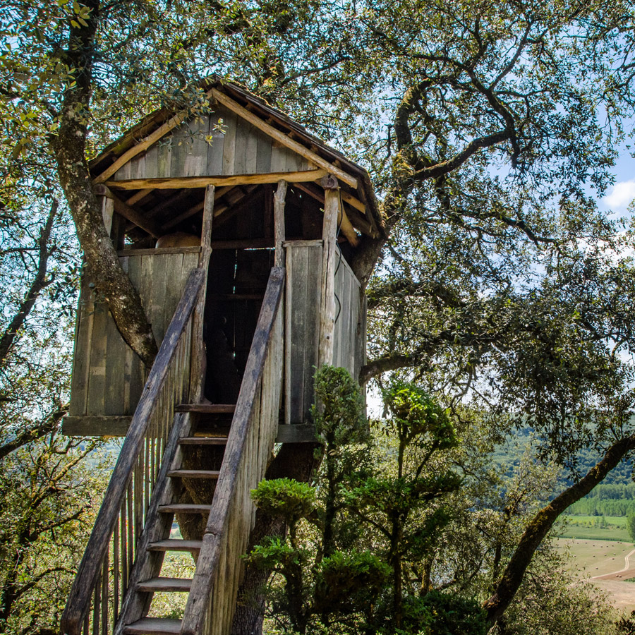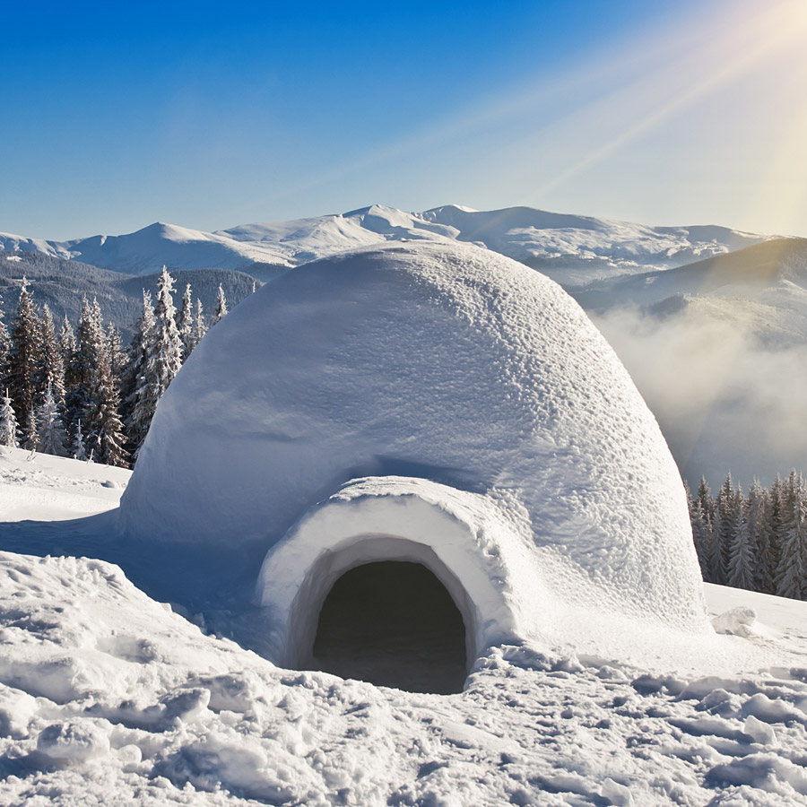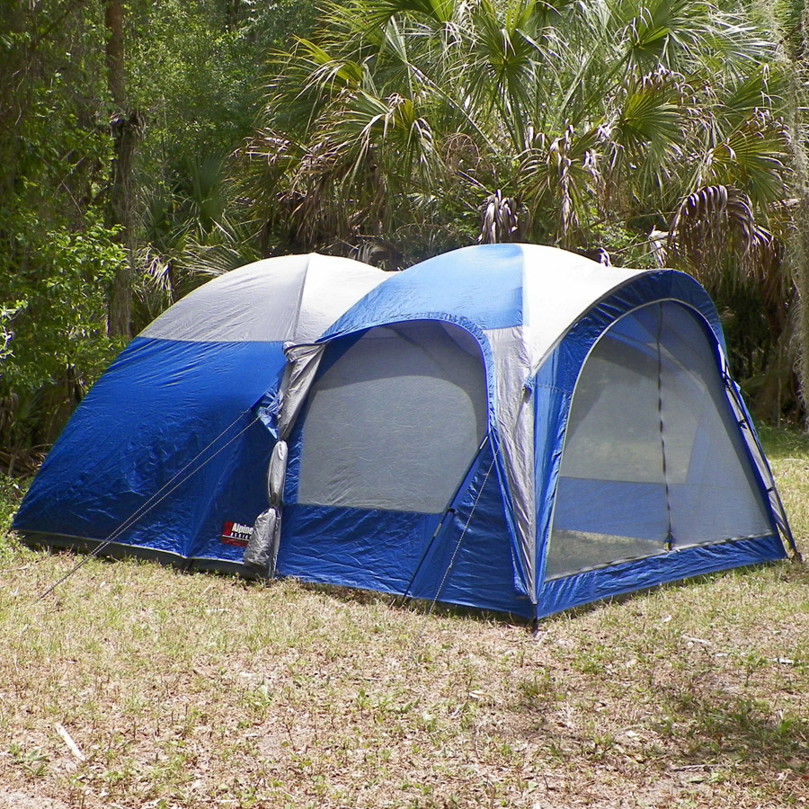
- Look at the three images above. Come up with as many similarities and differences as you can.
Think about:
- appearance
- what they do
- where they might be found
- Now decide which one is the odd one out and why. Be sure to explain your reason - there is no wrong answer!

---------------------------------------------------------------------------------------------

Background science
The shelters are a treehouse, an igloo and a camping tent. They are all temporary types of shelter built within an environment from either materials at hand or something taken with you.
----------------------------------------------------------------------------------------------
Task
Can you find out about other homes and shelters from around the world built from natural resources.
Or, get practical with this mini-den building exercise from the Eden Project https://www.edenproject.com/learn/schools/lesson-plans/den-designers.

