Home Learning
https://explorify.wellcome.ac.uk/
Odd One Out – Topsy Turvy
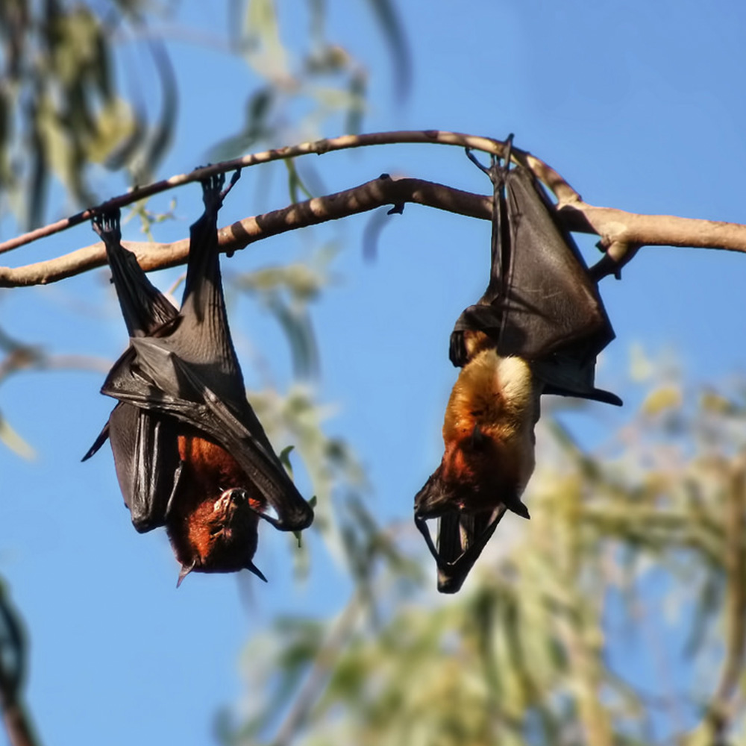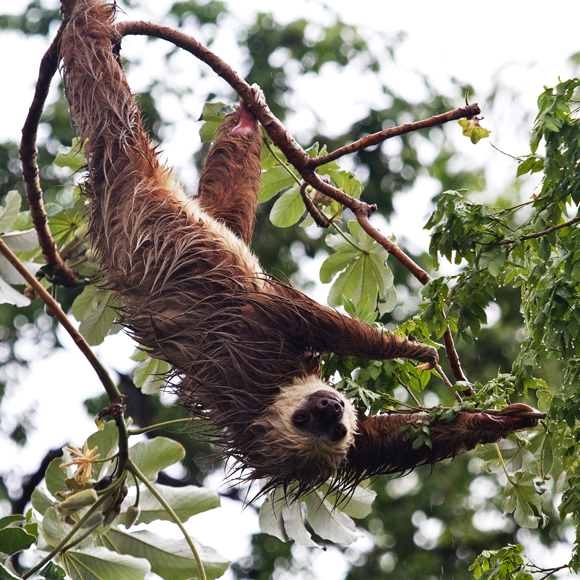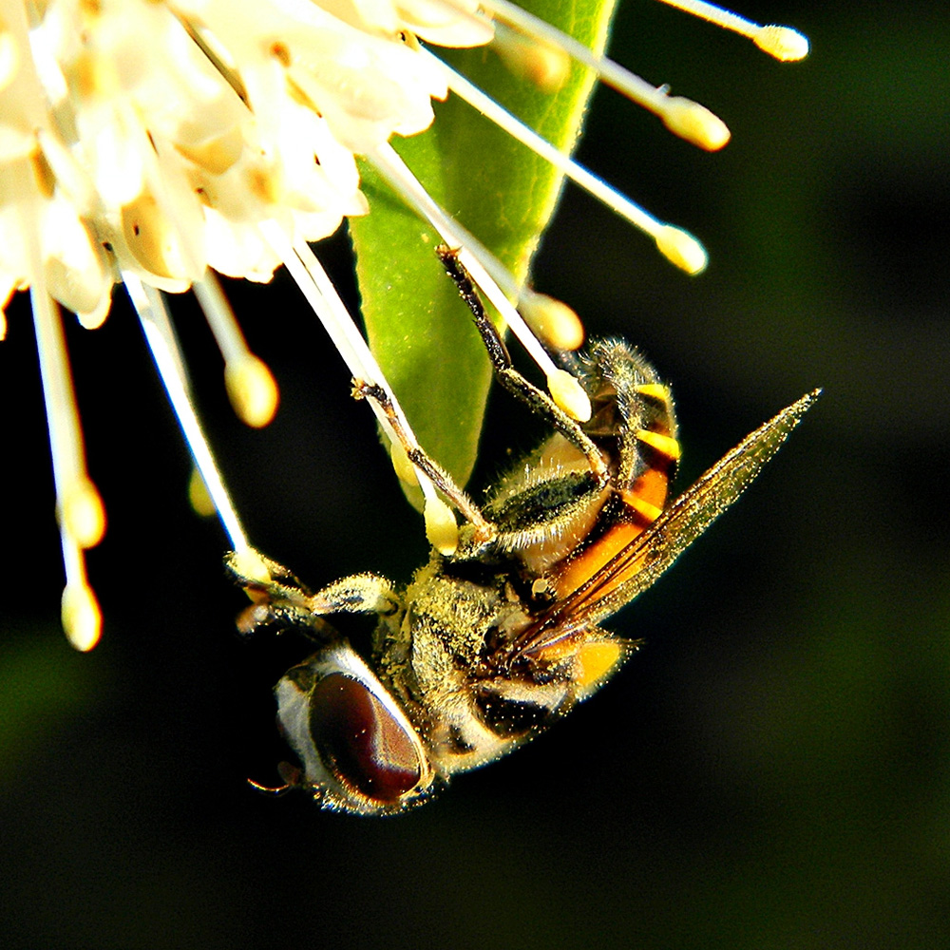
- Look at the three images above. Come up with as many similarities and differences as you can.
Think about:
- appearance
- what they do
- where they might be found
- Now decide which one is the odd one out and why. Be sure to explain your reason - there is no wrong answer!

---------------------------------------------------------------------------------------------

Background science
Sloths have evolved to spend much of their lives hanging upside down. Hanging below branches makes them less visible to predators. They spend so much of their lives upside down their fur lies the opposite way from most mammals. Sloths have curved claws that act like hooks to keep them suspended.
Some insects, like the drone fly, have specialized feet that allow them to walk on seemingly impossible places. They have hairs that produce glue-like substances to help them stick, and tiny claws that help them get unstuck to keep moving.
Because bats and flying foxes have different wings to birds, they can't take off from the ground like birds. Sleeping upside down from a high location like a tree or cave allows them to quickly escape if they need to. Hanging upside down also allows them to nab secret hiding spot from predators, as most animals can't hang upside down. Bats and flying foxes have tendons that lock to keep them hanging.
----------------------------------------------------------------------------------------------
Task
Explore the food chains for these three animals, looking at what predators they might be hiding from and if their upside-down living helps them find food. How are they suited to their environments?

