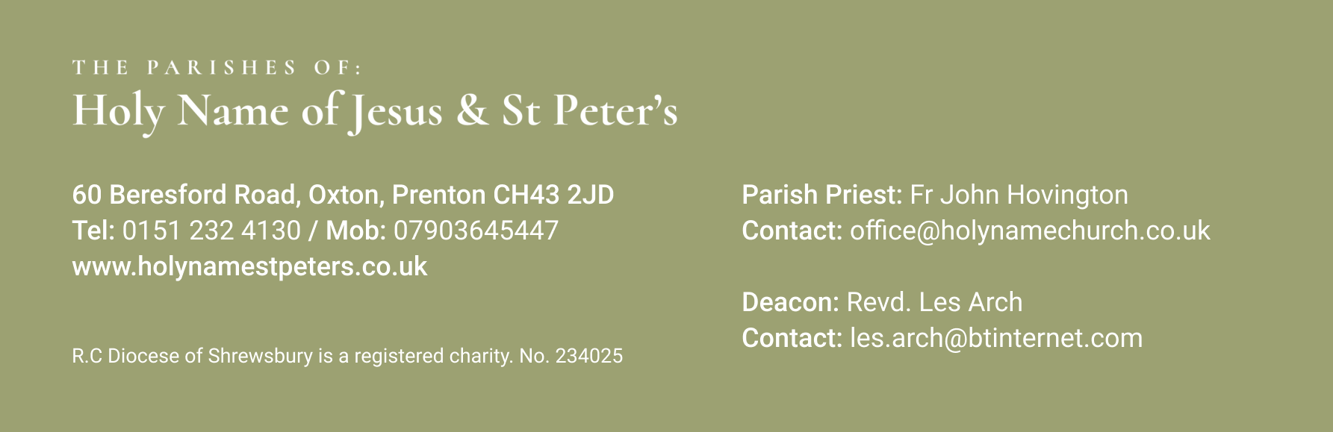

23rd June 2024 Twelfth Sunday in Ordinary Time

Mass Times:
Saturday 22nd June | 5.30pm | Holy Name | Derek Whittle
Sunday 23rd June | 9.30am | St Peter’s
 | 11.30am | Holy Name | Mary & Kevin Nolan
Monday 24th June | 9.30am | Holy Name | Barbara Noble
Tuesday 25th June | 9.30am | St Peters
Wednesday 26th June | 9.30am | Holy Name | Doreen Sutton
Thursday 27th June | No Mass
Friday 28th June | 9.30am | St Peters
Saturday 29th June | 5.30pm | Holy Name
Sunday 30th June | 9.30am | St Peter’s
 | 11.30am | Holy Name | Anna Rees
Again, with the Newsletter, are the Sunday Mass Readings so that you have them to read at Mass in Church or online at home.
Doreen Sutton’s funeral is at Landican at 1pm on Wednesday and I have put her intention down for the 9.30am Mass.
After the 11.30am Mass on Sunday I will be going across to St Joseph’s in Sale to do the baptism of one of my cousin’s latest grandchildren. When they have a priest in the family, they keep him well in demand!! It is always nice to see the next generation growing up and the generation after that!

**********************************
Your prayers Please pray for those who are celebrating significant anniversaries at this time of year and those who are sick: Kay Doran, Eve Perry, Emma Kelly, Geraldine Newton, Margaret Rose Gillam, John and Julia Delaney, Maureen Denyer, Patricia Lacey, Paola Fregona, Kevin Nolan, Daniel Dobbs, Anja Welsh-Smyth, Connor O’Mahoney, Joan Smith, Paschal Welsh, Jenny Fogg, and Maria Jones

***********************************
Food Bank I thank you for your support to the food bank. Please leave any donations in the Porch of St Peter’s Church or the Presbytery Porch at Holy Name. Your support is particularly important because, as might be expected in these times of hardship, food donations have not been keeping pace with increased need. Items particularly needed at present include: Tinned meat, tinned fruit, tinned potatoes, pasta sauce, and custard.

***********************************

Parish BBQ Holy Name and St.Peters annual parish BBQ is on Sunday 14th July from 1pm in Holy Name Garden. All are welcome. There will be lists in the porch of both churches, if you could fill in Name and number of people attending that will help with the catering. The social committee will provide all the BBQ food as well as red/white wine, beer, soft drinks and tea and coffee. All we ask is that if possible you could bring one plate of food either savoury or sweet to supplement a shared table. We will have a bouncy castle and have a raffle. If you have your own garden chairs it would help if you could bring them with you. ENQUIRIES Pauline Eriksen 07982314029

************************************
Snowdon at Night Helen Hart has written to thank everyone who donated for her walk in support of Claire House Children's Hospice. She raised £1,250 after starting walking at 1am in the morning and getting to the summit at 5.30am.

***********************************
Lourdes Pilgrimmage: ‘Go tell the priests to come [here] in procession’ is the theme of this year’s Diocesan Pilgrimage to Lourdes from 26 July to 1 August (depending on travel). We are expecting more pilgrims to journey with us this year, and it will be our largest pilgrimage since the pandemic. There are still some places available if you would like to join us this year. For more information, please see the pilgrimage website www.shrewsburypilgrimage.co.uk or phone the Pilgrimage Office on 07970943940.

***********************************

“A newspaper reporter sent a telegram to Cary Grant, asking, HOW OLD CARY GRANT? He replied, OLD CARY GRANT FINE, HOW YOU?”

“It’s better to wear out than to rust out.” Richard Cumberland (1631-1718)

“Always be sincere, even if you don’t mean it.” Harry S Truman (1884-1972)

“If you don’t find God in the very next person you meet, it is a waste of time looking any further.” Mahatma Ghandi (1869-1948)

