Home Learning
https://explorify.wellcome.ac.uk/
Odd One Out – Burly Bridges
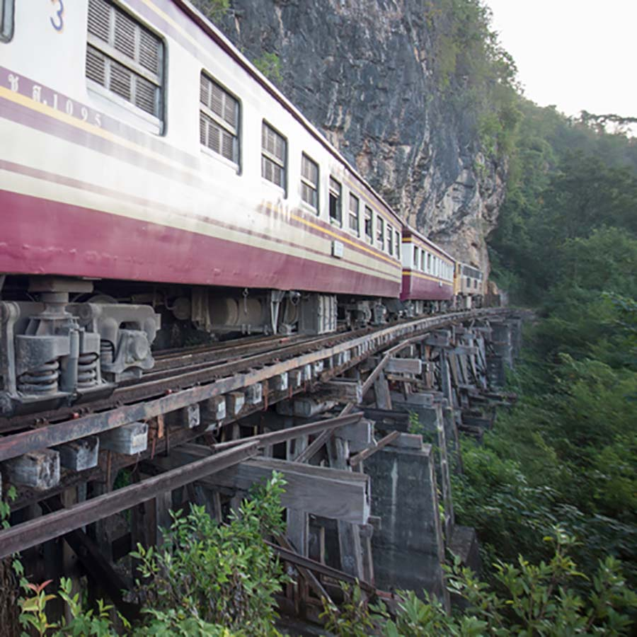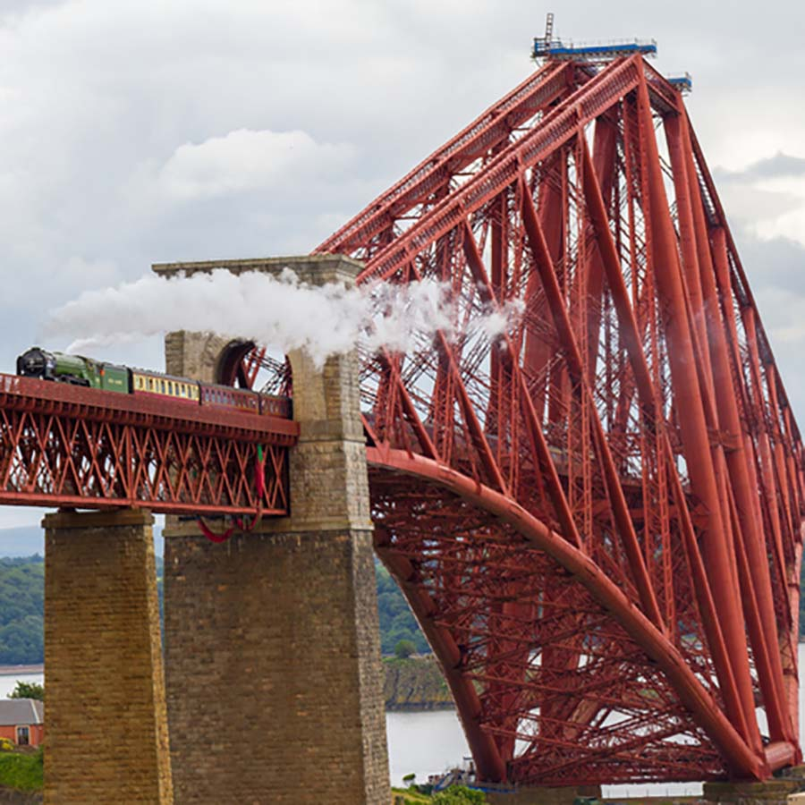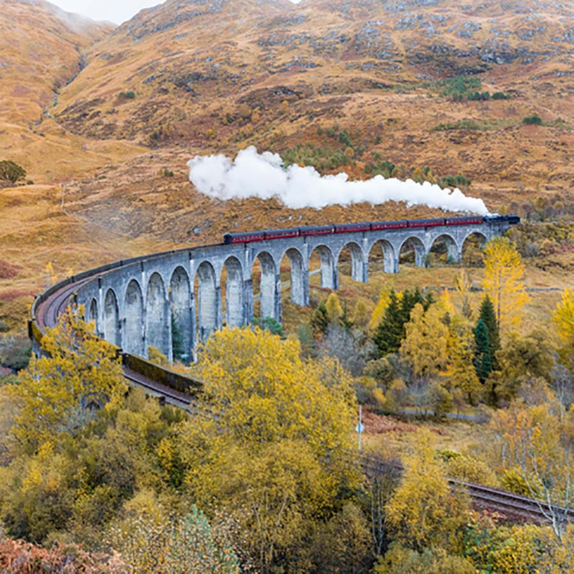
- Look at the three images above. Come up with as many similarities and differences as you can.
Think about:
- appearance
- what they do
- where they might be found
- Now decide which one is the odd one out and why. Be sure to explain your reason - there is no wrong answer!

---------------------------------------------------------------------------------------------

Background science
The images are all of railway bridges, found in different locations around the world. In all the bridges the railway tracks are made of metal (steel). This is chosen because it is a cheap but strong and hard material. The material of the actual bridges differs in each image.
The first image shows a wooden bridge in Thailand. Wood is a strong material and is plentiful in this area of the world, which is covered in forests. It is natural and renewable.
The second image shows the Forth Bridge in Scotland. This bridge is made of steel. Steel is a man-made material made from iron. It is very strong but it can rust when it comes into contact with water and air. The bridge is painted to protect it from rusting.
The third image shows another bridge in Scotland. This is a viaduct built of concrete. Concrete is a man-made material which is strong, hard and resistant to weathering.
----------------------------------------------------------------------------------------------
Task
Find some suitable materials in your home and build a bridge between two surfaces (chairs). What would happen to your bridge is you used stretchy material?

