Home Learning
https://explorify.wellcome.ac.uk/
Odd One Out – Shoot the Breeze
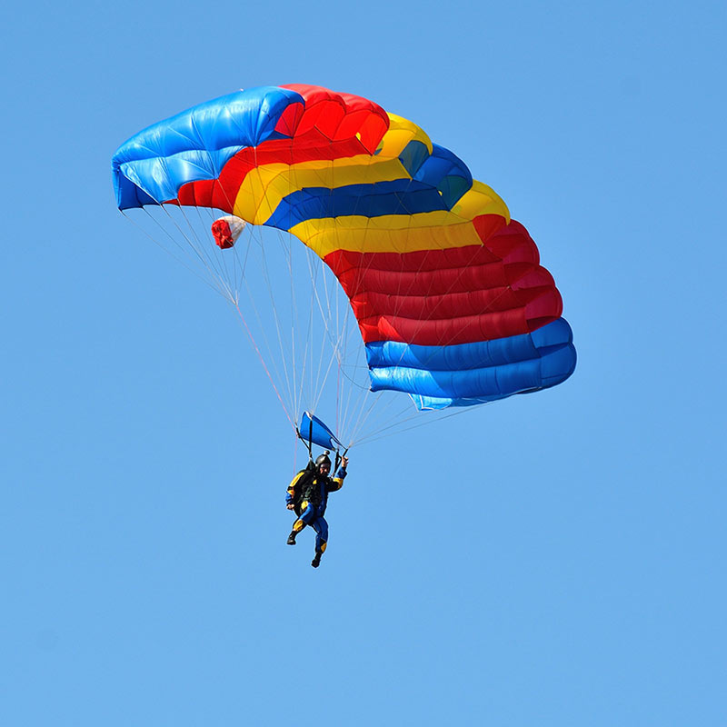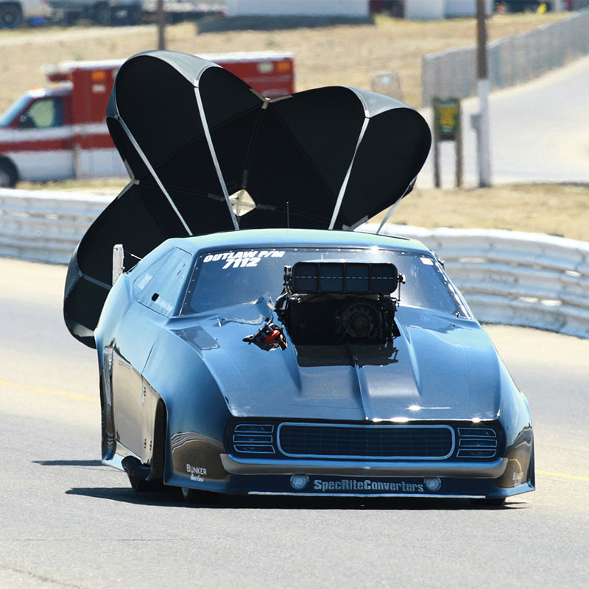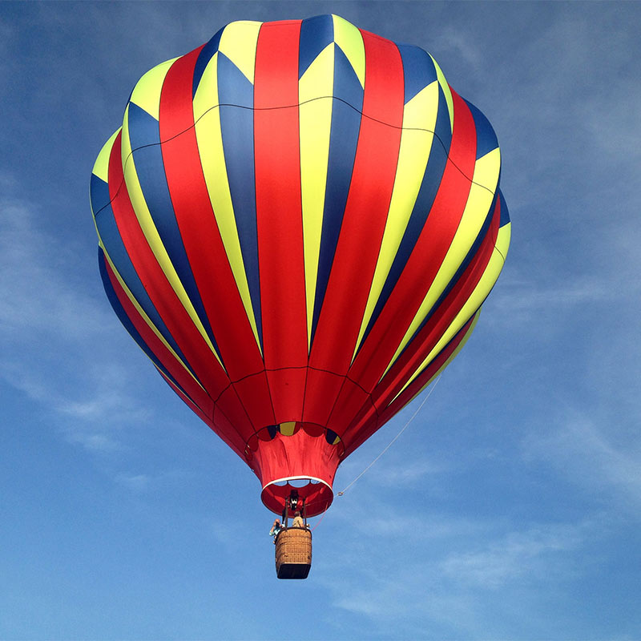
- Look at the three images above. Come up with as many similarities and differences as you can.
Think about:
- appearance
- what they do
- where they might be found
- Now decide which one is the odd one out and why. Be sure to explain your reason - there is no wrong answer!

---------------------------------------------------------------------------------------------

Background science
The three images show how air resistance is used in parachuting, to slow a vehicle and in a hot air balloon.
Air resistance, or drag, is a force. In the parachute and hot air balloon, air resistance is acting against gravity but in the vehicle, the drag force acts in opposition to the forward motion of the vehicle slowing it down.
This BBC video(https://www.bbc.co.uk/bitesize/clips/zsjd7ty) gives an overview of air resistance and this clip (https://www.bbc.co.uk/teach/class-clips-video/investigating-what-makes-a-good-parachute/zjps382) shows how parachutes use air resistance to slow falling objects.
----------------------------------------------------------------------------------------------
Task
Can you take what you've learnt from this activity and use your findings to create a parachute for an egg? This tutorial (https://www.education.com/science-fair/article/egg-parachute/) outlines how to use plastic bags and string to get an egg safely in the air.
You can watch Terrific Scientific's Live Lesson on forces to learn more about resistance andfriction. (https://www.bbc.co.uk/programmes/articles/5CBvkQZpJyC1zTVzsLmVQQt/terrific-scientific-forces-live-lesson)

