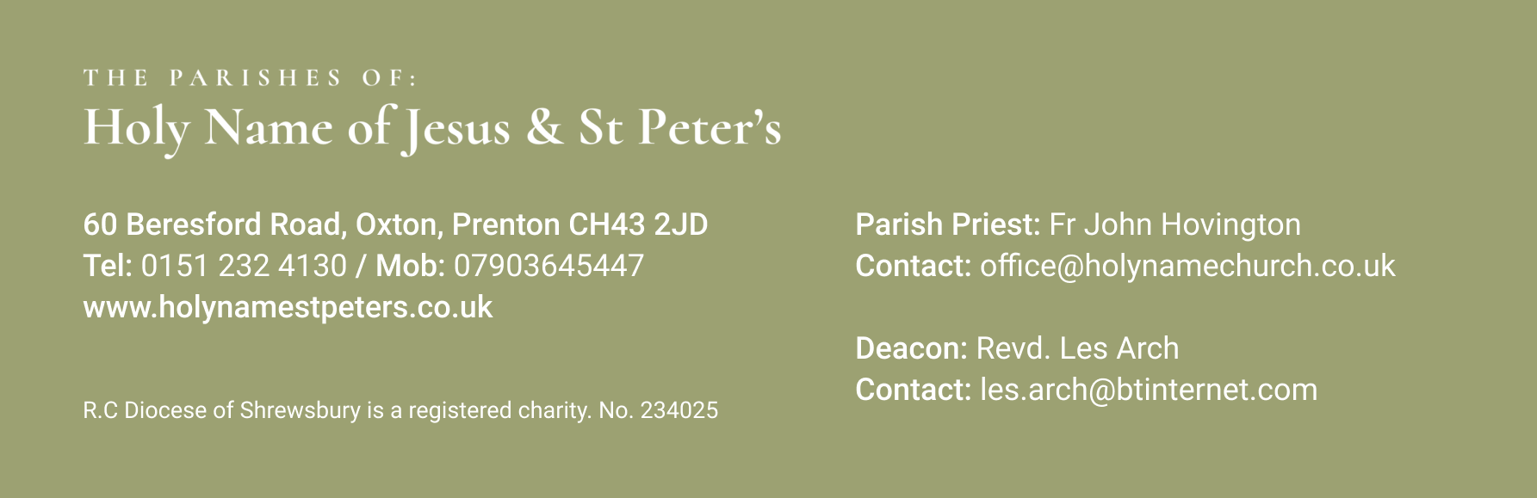

1st September 22nd Sunday of the Year B

Mass Times:
Saturday 31st Aug | 5.30pm | Holy Name
Sunday 1st Sept | 9.30am | St Peter’s | Sian Lewis
 | 11.30am | Holy Name
Monday 2nd Sept | 9.30am | Holy Name
Tuesday 3rd Sept | 9.30am | St Peter’s
Wednesday 4th Sept | 9.30am | Holy Name | Anthony Caslin
Thursday 5th Sept | No Mass
Friday 6th Sept | 9.30am | St Peter’s
Saturday 7th Sept | 5.30pm | Holy Name | Laura Noonan
Sunday 8th Sept | 9.30am | St Peter’s | Mikey Purnell
 | 11.30am | Holy Name | Rose McNally

Again, with the Newsletter, are the Sunday Mass Readings so that you have them to read at Mass in Church or online at home.
Our Schools return next week: St Peter’s and St Joseph’s staff are back on Monday 1st Sept and the children are in on the Tuesday 2nd Sept. Isn’t it strange that the weather often changes to a lovely sunny spell as the children go back to school after a relatively miserable holiday time!!
One of my Nephews, Benedict, is in a play opening at The Ambassadors Theatre in the West End London. It is entitled The Curious Case of Benjamin Button. All the actors play musical instruments and sing. Obviously I will be going down to see him and the rest of the cast perform, but I am letting you know about the musical in case any of you are thinking of spending any time in London over the Xmas period and might be interested in seeing it. You can find one or two short promotion videos on the internet.

**********************************
Your prayers Please pray for those who are celebrating significant anniversaries at this time of year and those who are sick: Kay Doran, Eve Perry, Emma Kelly, Geraldine Newton, Margaret Rose Gillam, John and Julia Delaney, Maureen Denyer, Patricia Lacey, Paola Fregona, Kevin Nolan, Daniel Dobbs, Anja Welsh-Smyth, Connor O’Mahoney, Joan Smith, Paschal Welsh, Jenny Fogg, Kathryn Farrell and Maria Jones

***********************************
Food Bank Thank you for your support to the food bank. Please leave any donations in the porch of St Peter’s church or the Presbytery porch at Holy Name. Items particularly needed at present include: cereals, tinned vegetables, tinned fruit, pasta sauce and custard.

***********************************
Fundraising for SVP Youth Kate Birkenhead (SVP Officer for the Shrewsbury Diocese) and her partner Colin will be walking the whole of the Shrewsbury Diocese: 200 plus miles from New Brighton on The Wirral to Ludlow in South Shropshire, via South Manchester, raising money for our local St Vincent De Paul Society Children’s Camps and Holiday homes. They will take 2 weeks in July/August to complete the walk. All money raised will go towards funding these vital initiatives. https://giving.give-star.com/online/saint-vincent-de-paul-society-england-and-wales/kate-and-colin-are-walking-the-length-and-breadth-of-shrewsbury-diocese
***********************************
Jesus March around Wirral The vision is a one-day prayer walk around the coast of Wirral on 17th August. It will be broken down into 12 smaller walks and 12 prayer tents dotted around the Wirral in preparation for an ‘Outpouring Event’ in the New Brighton Dips September 27th – 30th. More information can be found at JESUSOUTPOURING@GMAIL.COM
or through Sophie 07841463430 There is a poster in the Church Porch

**************************************
Lourdes Hospitality Members "Shrewsbury Lourdes Hospitality members are warmly invited to a ‘Day of Reflection’ on Saturday 14 September, at Shrewsbury Cathedral. Led by Fr Sean Henry, the theme will be, “Martha and Mary: The Hospitality we give to Christ”. 9.15am start with a 3.30pm finish. Lunch can be purchased on site, or bring your own. Cost (by anonymous donation). Spaces are limited so please book early. For further details, please contact Clare, secretary@teamshrewsbury.co.uk or text Siobhan on 07931574348.”

***********************************
Pause for Hope Service Pause for Hope is an ecumenical service for all those suffering from cancer, those caring for family or friends with cancer, and those affected in any way by cancer. This year the service takes place on Sunday 15 September at 3pm in Saint Columba’s church, Chester. It is an opportunity to come together to pray and to support one other. There is a Poster displayed in the Porch of both Holy Name and St Peter’s Churches
**********************************

