Home Learning
https://explorify.wellcome.ac.uk/
Odd One Out – Get your blood pumping.
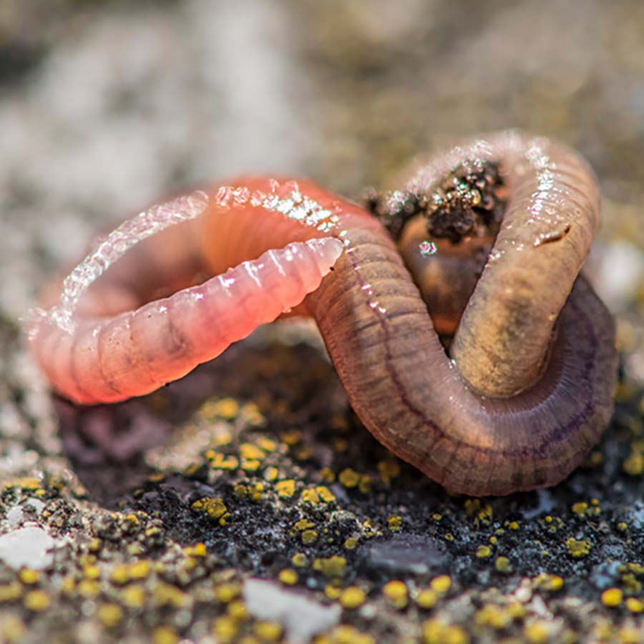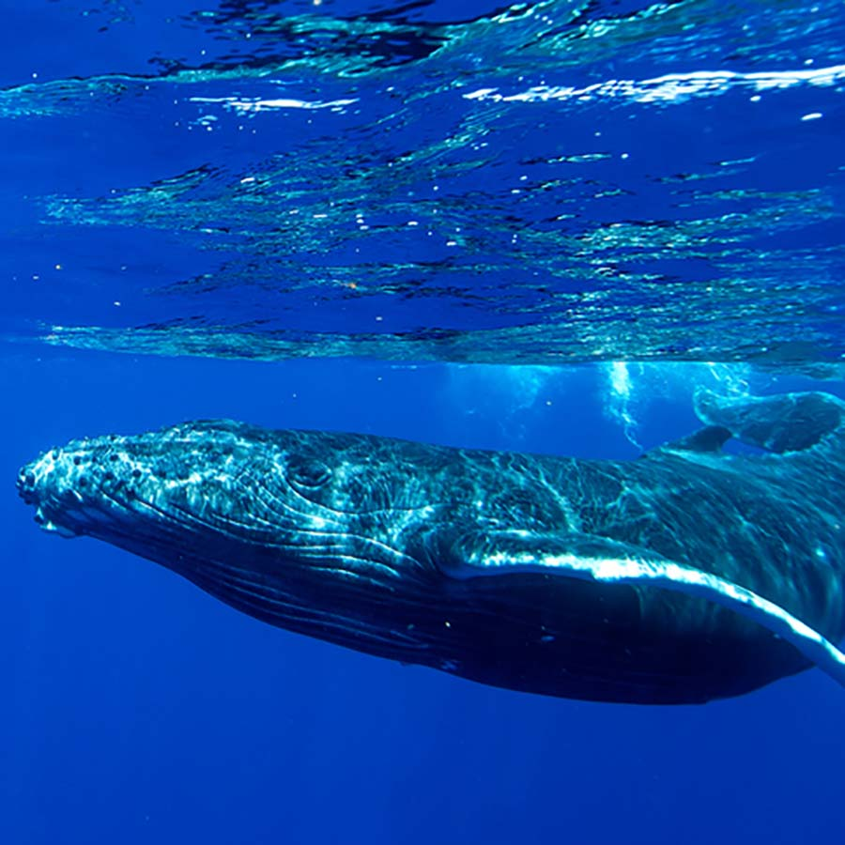
- Look at the three images above. Come up with as many similarities and differences as you can.
Think about:
- appearance
- what they do
- where they might be found
- Now decide which one is the odd one out and why. Be sure to explain your reason - there is no wrong answer!

---------------------------------------------------------------------------------------------

Background science
The images show a humpback whale, a human and an earthworm.
Both the humpback whale and human are mammals, so their circulatory systems are very similar. They both contain a heart that pumps blood around the body inside tubes called blood vessels. Mammals have a double circulatory system. This means that blood passes through the heart twice in each circuit – once to pump it to the lungs to pick up oxygen (and remove carbon dioxide), before returning to the heart to be pumped around the rest of the body so that blood can deliver oxygen to the tissues.
The earthworm is an invertebrate animal. It doesn't have lungs, rather oxygen is absorbed through the skin into blood vessels. The blood is pumped around its body by five small hearts.
----------------------------------------------------------------------------------------------
Task
Find out more about the human circulatory system with this BBC clip: https://www.bbc.co.uk/bitesize/topics/zwdr6yc/articles/zs8f8mn Do their own research into the circulatory systems of other animals, for example, fish, insects and snails. How are they different to that of a human?

