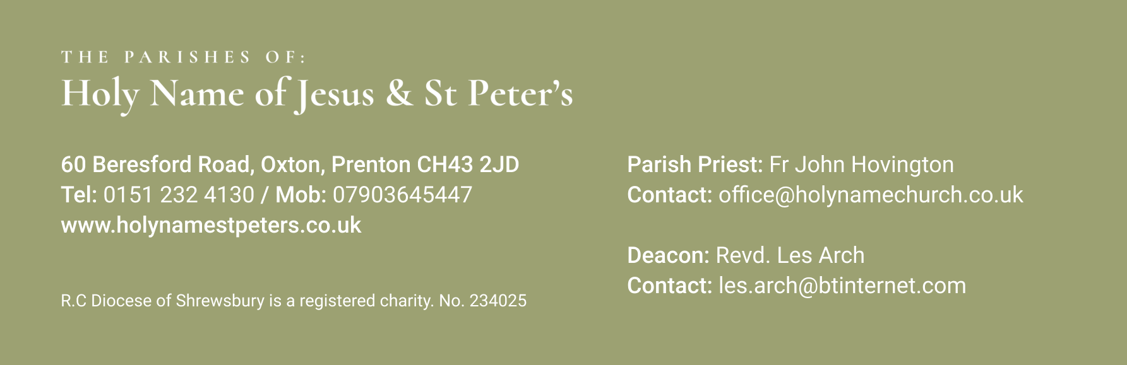

1st December 2024 First Sunday of Advent
Mass Times:
Saturday 30th November | 5.30pm | Holy Name | Peter Howard (Ann)
Sunday 1st December | 9.30am | St Peter’s | Mario Santos
 | 11.30am | Holy Name | Anne McNicholas McCluskey
Monday 2nd December | 12 noon | Holy Name | Funeral of Doreen Pownall
Tuesday 3rd December | 9.30am | St Peter’s
Wednesday 4th December | 9.30am | Holy Name | Ann Parsons (Special Int)
Thursday 5th December | No Mass
Friday 6th December | 9.30am | St Peter’s
Saturday 7th December | 5.30pm | Holy Name
Sunday 8th December | 9.30am | St Peter’s | Peter Stead
 | 11.30am | Holy Name
Again, with the Newsletter, are the Sunday Mass Readings so that you have them to read at Mass in Church or online at home.
This weekend we begin a new Church year as we celebrate the first Sunday of Advent. We look forward to welcoming Jesus in his coming at the Feast of Christmas in four week’s time. To help our preparation we will have a penitential service with absolution later in Advent. I will give you adequate notice.
You will notice that Mass on Monday is the Requiem for Doreen Pownall who died recently. I hope that if your thinking of coming for Monday morning Mass you will still come to support Doreen’s family on this sad occasion. Mass is at 12noon
***********************************
Your prayers Please pray for those who are celebrating significant anniversaries at this time of year and those who are sick: Kay Doran, Eve Perry, Emma Kelly, Geraldine Newton, Margaret Rose Gillam, John and Julia Delaney, Brian Farrell, Maureen Denyer, Patricia Lacey, Paola Fregona, Kevin Nolan, Daniel Dobbs, Anja Welsh-Smyth, Connor O’Mahoney, Paschal Welsh, Jenny Fogg, Nelia Fregona and Maria Jones.
***********************************
Food Bank I thank you for your support to the food bank. Please leave any donations in the Porch of St Peter’s Church or the Presbytery Porch at Holy Name. Items particularly needed at present include: Tinned fruit, tinned potatoes, tinned spaghetti , cereal and treats (chocolate etc).
***********************************
ADVENT RETREAT (AGE 15 TO YOUNG ADULTS) AT CASTLERIGG MANOR Bookings will close for the Advent Retreat at Castlerigg on December 11th at Midday. The open retreats at Castlerigg give teens and young adults a great way to make friends, deepen their faith, and have some fun and they usually prove very popular. The weekend costs £65 but anyone who might struggle with this is invited to get in touch. Further details – director@castleriggmanor.co.uk. Sign up at castleriggmanor.com >> what’s coming up.
***********************************
Vacancies Two Administrator vacancies, (full time: 35 hours and part time: 25 hours) have arisen within our Inter-Diocesan Fuel Management Department, which is a Catholic organisation purchasing gas, electricity, fuel oil and biomass for all Catholic Dioceses in England and Wales. Salary: £23K to £25K (pro rata) depending on experience. Further details can be found via our Diocesan website https://www.dioceseofshrewsbury.org/latest-vacancies/ completed application should be sent to Pauline McCulloch, recruitment@dioceseofshrewsbury.org Closing date Friday 29 November 2024.
***********************************
Advent Talks You are invited to a series of talks in Advent to coincide with the launch of the New Lectionary at the Parish Hall, Holy Angels, Hale Barns, Altrincham, WA15 0HG. At 7pm on Wednesday 4th December we are delighted to welcome Fr Paul Denney who is a priest of the Diocese of Motherwell, Scotland. He has a Licentiate in Scared Scripture from the Pontifical Biblical Institute. He has recently served on the editorial board for the new lectionary as the delegate of the Bishops’ Conference of Scotland. He will speak to us about the new translation of the Lectionary that we will be using at Mass. (I will give you details of the other talks as they come up for the following two Weeks)
***********************************
CAFOD school volunteers needed! Could you visit your local Catholic school to talk about the work of CAFOD? We are looking for volunteers in the Shrewsbury Diocese to deliver school assemblies and workshops to inspire children and young people to make a difference and take action. For further information please contact Anna on 07710 094449 or email aletizia@cafod.org.uk
Service of Carols and Readings There will be a Service of Carols and Readings on Sunday 15th December 2024 at 2pm in St Michael and All Angels Church, Woodchurch. Music is by The Parish and 3 L’s Choir. Admission is by ticket as capacity is limited. I have been given a limited number of tickets so please let me know if you need one. Proceeds supporting Arrow park and Clatterbridge Hospitals. See poster in Church Porch.
***********************************

