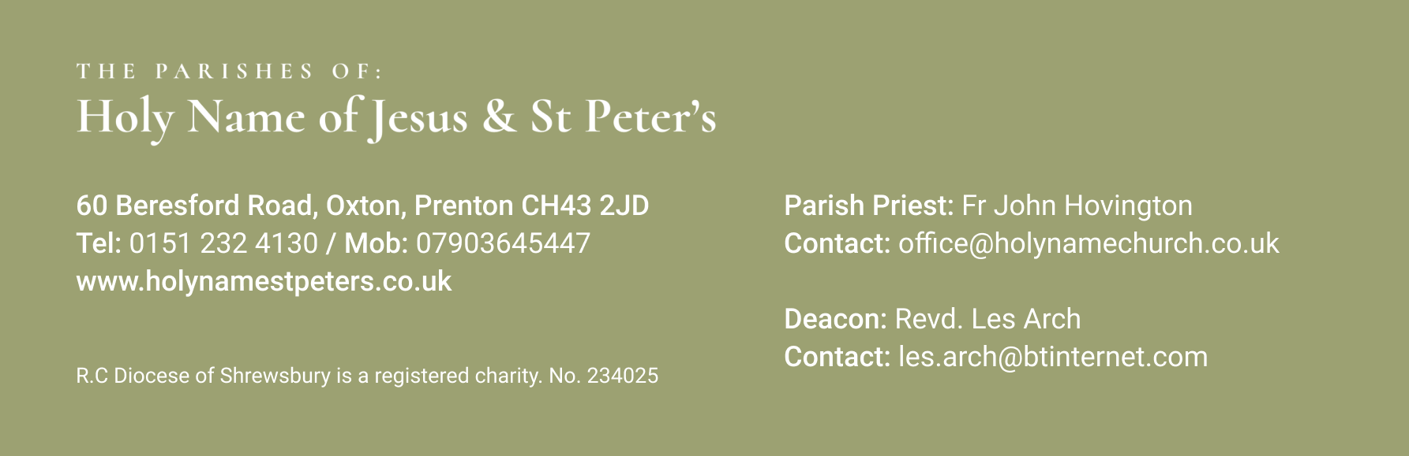

9th March 2025 1st Sunday of Lent
Mass Times:
Saturday 8th March | 5.30pm | Holy Name | Alan Knowles & Mario Santos
Sunday 9th March | 9.30am | St Peter’s
 | 11.30am | Holy Name
Monday 10th March | 9.30am | Holy Name
Tuesday 11th March | 9.30am  7.00pm | St Peter’s  Holy Name | Stations of the Cross
Wednesday 12th March | 9.30am | Holy Name
Thursday 13th March | No Mass
Friday 14th March | 9.30am | St Peter’s
Saturday 15th March | 5.30pm | Holy Name
Sunday 16th March | 9.30am | St Peter’s
 | 11.30am | Holy Name | Parishioners
Again, with the Newsletter, are the Sunday Mass Readings so that you have them to read at Mass in Church or online at home.

***********************************
Your prayers Please pray for those who are celebrating significant anniversaries at this time of year and those who are sick: Kay Doran, Eve Perry, Emma Kelly, Geraldine Newton, Margaret Rose Gillam, John and Julia Delaney, Brian Farrell, Maureen Denyer, Patricia Lacey, Paola Fregona, Kevin Nolan, Daniel Dobbs, Anja Welsh-Smyth, Connor O’Mahoney, Paschal Welsh, Jenny Fogg, Nelia Fregona and Maria Jones.

************************************
Food Bank I thank you for your support to the food bank. Please leave any donations in the Porch of St Peter’s Church or the Presbytery Porch at Holy Name. Items particularly needed at present include: Tampons, Tinned Fruit, Tinned Potatoes and Tinned Spaghetti, Milk and Cereal.

***********************************

A Night at the Musicals St Philip Neri Parish (St Joseph’s and St Michael and All Angels) are holding a concert performed by the Warrington Male Voice Choir on Friday 4th April at 7.30pm at St Michael and All Angels, Woodchurch. We invite you to join us at what we are sure will be a thoroughly enjoyable evening. Tickets priced £8 are available from the Parish Office 652 5767 or by contacting Deacon Gerard Boyle 07742 659728.
************************************
Red Box Collection If you have a Missio Red Box that needs emptying, please bring it Mass this weekend or next (8/9 March). and give it to Fr John or to Lesley Evans (07734 033772). If you are unable to come to church please let Lesley know and she will arrange to collect your box. Many thanks for your continued support.
************************************

Golden Jubilee Fr Hov has a double celebration coming up in April. The 19th April marks the 50th Anniversary of his ordination to the priesthood: and on 21st April, he will celebrate his 75th birthday.
As a Parish we are planning to mark these prestigious events with, and for, Father John who has been a wonderful parish priest for us all. Due to Easter Sunday falling on the 20th this year our celebrations are planned for Saturday 26th April.
We have booked the Parish Club at St Joseph’s North Rd from 7pm on that Saturday evening. There will be a buffet, some live music and of course a presentation to Fr Hov. Tickets for the evening are limited and will be on sale after all Masses on the weekends of 15/16 March and 22/23 March. Tickets will cost just £5 towards the cost of the buffet and will be sold on a strictly first come first served basis. Tickets cannot be reserved and must be paid for in cash.
There will be an opportunity in the coming weeks for parishioners to contribute to Fr Hov’s presentation and no doubt you will be as generous as always (labeled envelopes will be provided and we request donations in cash).
The 5.30 evening Mass on 26th April will be concelebrated by Bishop Tom Williams (a lifelong friend of Father’s) and of course all are welcome at this Mass

************************************

