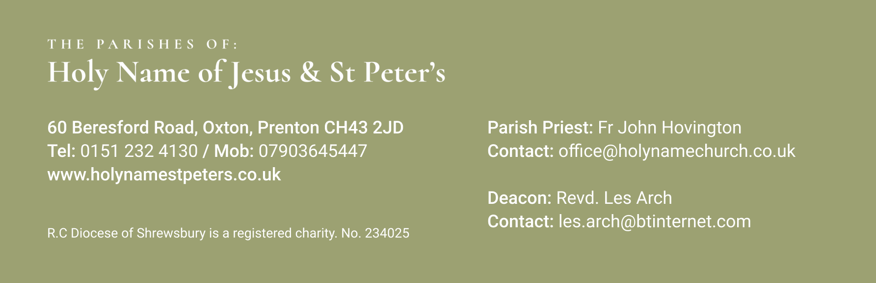

16th June 2024 Eleventh Sunday in Ordinary Time
Mass Times:
Saturday 15th June | 9.30am  5.30pm | St Peter’s  Holy Name | 1st Communion Mass
Sunday 16th June | 9.30am | St Peter’s
 | 11.30am | Holy Name | Parishioners
Monday 17th June | 9.30am | Holy Name | Maria Parkinson
Tuesday 18th June | 9.30am | St Peters | Mary McAteer
Wednesday 19th June | 9.30am | Holy Name | Mike Curry
Thursday 20th June | No Mass
Friday 21st June | 9.30am | St Peters
Saturday 22nd June | 5.30pm | Holy Name | Derek Whittle
Sunday 23rd June | 9.30am | St Peter’s | Parishioners
 | 11.30am | Holy Name | Angela Byrne
Again, with the Newsletter, are the Sunday Mass Readings so that you have them to read at Mass in Church or online at home.
Congratulations to all who made their First Communion this weekend.
I went to the hospital on Tuesday thinking it was for the Eye Clinic only to find out it was for Pacemaker Clinic, the nurse said she was putting me on the waiting list to have it replaced as the Battery is getting old. I got a letter on Thursday to say I was to come into Arrowe Park for 12noon on Thursday 4th July to have it done!! That’s service for you!!
Sadly I have to announce that Doreen Sutton died recently and that her Funeral is on Wed 26th June at Landican at 1pm.
**********************************
Your prayers Please pray for those who are celebrating significant anniversaries at this time of year and those who are sick: Kay Doran, Eve Perry, Emma Kelly, Geraldine Newton, Margaret Rose Gillam, John and Julia Delaney, Maureen Denyer, Patricia Lacey, Paola Fregona, Kevin Nolan, Daniel Dobbs, Anja Welsh-Smyth, Connor O’Mahoney, Joan Smith, Paschal Welsh, Jenny Fogg, and Maria Jones

Food Bank I thank you for your support to the food bank. Please leave any donations in the Porch of St Peter’s Church or the Presbytery Porch at Holy Name. Your support is particularly important because, as might be expected in these times of hardship, food donations have not been keeping pace with increased need. Items particularly needed at present include: Tinned meat, tinned fruit, tinned potatoes, pasta sauce, and custard.
***********************************
Parish Secretary A vacancy has arisen for a Parish Secretary at the parish of St Anne’s, Rock Ferry. Hours: 15 per week, to be spread over Monday to Friday mornings (flexible). hourly rate: £14.00. For further details please see the Diocesan Website https://www.dioceseofshrewsbury.org/latest-vacancies/ Applications in the form of a CV and covering letter should be sent to Pauline McCulloch recruitment@dioceseofshrewsbury.org Closing date: This Friday 21 June 2024.
************************************
Parish BBQ Holy Name and St.Peters annual parish BBQ is on Sunday 14th July from 1pm in Holy Name Garden. All are welcome. There will be lists in the porch of both churches, if you could fill in Name and number of people attending that will help with the catering. The social committee will provide all the BBQ food as well as red/white wine, beer, soft drinks and tea and coffee. All we ask is that if possible you could bring one plate of food either savoury or sweet to supplement a shared table. We will have a bouncy castle and have a raffle. If you have your own garden chairs it would help if you could bring them with you. ENQUIRIES Pauline Eriksen 07982314029
************************************
LORD FIELD of BIRKENHEAD At Frank Field's request, his ashes will be interred at Birkenhead Priory on this Monday, 17th June, This will be a private ceremony but it will be followed by a service of thanksgiving for his work in Birkenhead, with readings chosen by him, at 2pm at Christ Church, Bessborough Rd, Birkenhead. The family say that all are welcome.
************************************
Ecumenical Accompaniment Programme in Palestine and Israel (EAPPI) Eyewitness Stories from Israel and the West Bank. Come and hear first-hand from Judy, Sue & Hannah, who have each spent three months in the West Bank as part of this ecumenical programme. What is daily life under occupation really like? What is the Israeli peace movement doing? What can be done to promote a just peace in Israeli-occupied Palestine? Thursday 20th June at 7pm, Liverpool Quaker Meeting House, 22 School Lane, Liverpool L1 3BT, ALL WELCOME! For more information please contact EAPPI on 020 7663 1144 or eappi@quaker.org.uk www.quaker.org.uk/eappi
***********************************
A Lively Musical Evening, to support SVP Youth Work, with The Mercy Brothers On Friday 21 June you are invited to an evening with The Mercy Brothers, a clergy-based band from the Salford and Shrewsbury Diocese. Funds raised will go to support for SVP Youth Work in the Shrewsbury and Salford Dioceses. Venue: Our Lady’s Social Club, Flint St, Stockport, SK3 8GE. Doors open at 7pm for a 7.30pm start. Tickets £15

